**PROJECT REPORT**

**Motion Sensor Home Security**

**Team** : 1. Bandari Srija

2. Polu Tharun Kumar Reddy

3. Chilakamarri Srinikethan Nydhruva

4. Kankipati Venkata Naga Sai Harsha Vardhan

**Internship :** GoalStreet

**(**Remote internship on IOT with Android)

**Contents:**

1. Introduction
2. Project Scope
3. Requirements
4. Project Description
5. Circuit Diagram
6. Project Code
7. Advantages
8. Disadvantages
9. References

**Introduction:**

* As per the recent analysis on the thefts that are being happening in the cities, towns and even villages. They have been gradually increasing due to inefficient security systems that are currently available.
* In order to eradicate these mischievous incidents, there is a necessity of such a system which can detect the movement of an unknown person in your home when they shouldn’t be.
* If the sensor detects any movement in its range, it gets tripped and a signal will be sent to the security system’s control panel, which will therefore connects to your monitoring center(in this case to the owner) and alerts you and the monitoring center to a potential threat in your home.
* This helps the household to monitor themselves through an application.

**Project Scope:**

The main aim of our project is to identify if any living being is entering into our home, malls, etc. So that we can identify if any unknown person enters and that message will be sent to Owner.

**Requirements:**

This system requires hardware and software requirements in order to achieve our goals in this project.

**Hardware Requirements:**

* NodeMCU ESP8266
* PIR Sensor
* LED
* Resistor

**Software Requirements:**

* Arduino IDE
* Blynk App

**Project Description:**

In this project we use a PIR motion sensor to detect the motion of a body and that information is sent to NodeMCU

And the LCD glows and message will be sent to Owner.

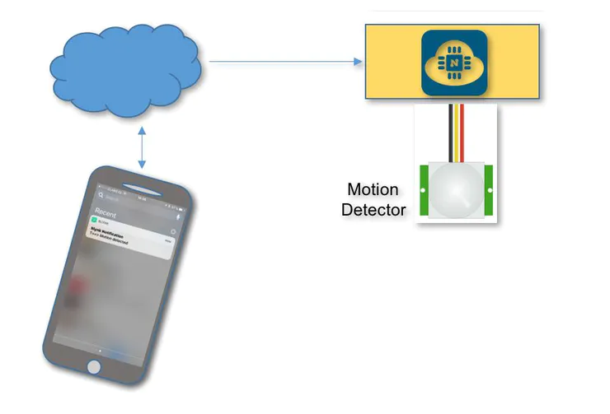

Fig1: PIR motion detection sensor working principle

Here a motion sensor is a device which uses one or multiple technologies to detect any sort of movement in a particular area of observation.

**Circuit Diagram:**

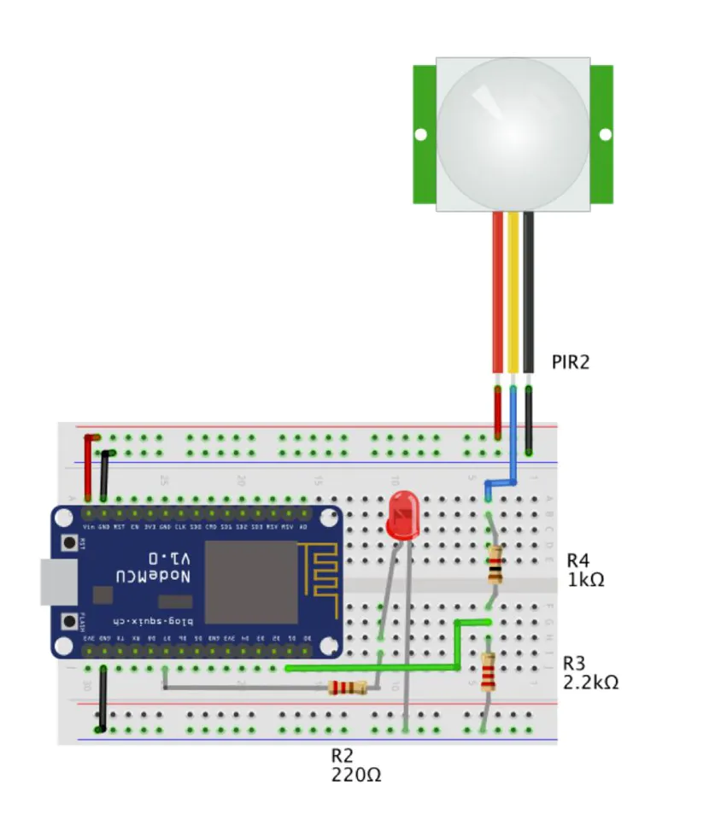

Fig2: Circuit Diagram of Motion Sensor Home Security

**Project Code:**

#include <ESP8266WiFi.h>

#define BLYNK_PRINT Serial

// Comment this out to disable prints and save space

#include <BlynkSimpleEsp8266.h>

char auth[] = "9kl8MjGTBX9wFp9H-0nOLQz11wQziJWO";

/* WiFi credentials */

char ssid[] = "Sriprahasita";

char pass[] = "****";

/* HC-SR501 Motion Detector */

int ledPin =13;

int pirPin =5; // Input for HC-S501

int pirValue; // Place to store read PIR Value

void setup()

{

Serial.begin(9600);

delay(10);

Blynk.begin(auth, ssid, pass);

pinMode(ledPin, OUTPUT);

pinMode(pirPin, INPUT);

digitalWrite(ledPin, LOW);

}

void loop()

{

getPirValue();

Blynk.run();

}

// Get PIR data

void getPirValue(void)

{

pirValue = digitalRead(pirPin);

if (pirValue)

{

Serial.println("==> Motion detected");

Blynk.notify("T==> Motion detected");

digitalWrite(ledPin, pirValue);

}

else

{

Serial.println("++>motion absent");

digitalWrite(ledPin, pirValue);

}

}

**Advantages:**

* Thefts can be controlled.
* Catch intruders before they break into your home.

**Disadvantages:**

* Any kind of moving object can trigger the PIR sensor type.

**References:**

<https://www.engineersgarage.com/esp8266/pir-motion-detector-with-nodemcu/>